V.I.R.U.S Game Components

kieran BOYCE, RYAN manning, harry statham, liam david

2020

# List of components

## Player cards

The player cards define how each player turn will go in each turn every card has its own action and will cost energy for the player to use so they need to be careful. How they don’t waste their turns. Here is what is on each card

* Wall – this allows the player to block the virus from spreading in a direction for a single round the wall then disappears

* Move in one direction

* Move in any direction

* Destroy virus – allows the player to destroy a virus piece close to them

* Give player extra move point – allows another player one extra move point

* Swap cards with players – allows players to swap a card with another player to help them out

* Lockdown – Forces the virus to draw one less card next turn but limits all movement to max 3 spaces

## Virus cards

The virus cards are how the virus will act throughout the game these don’t cost anything for the virus they are just able to use 2 cards at the beginning of every round.

* Move to surrounding all surrounding spaces

* Move in single direction – this will be in the direction of the colour of the die that gets rolled

* Duplicate – Duplicates an amount of spaces away in a given dice direction

* Get one extra turn indefinitely – this increases the number of cards the virus can use at the beginning of the round for the rest of the game

* Gain extra turns this round – Draw extra cards for this turn only

## Coloured die

This is going to be a coloured D6 mainly used to decide things such as movement or whether the virus is destroyed but only after certain conditions are met.

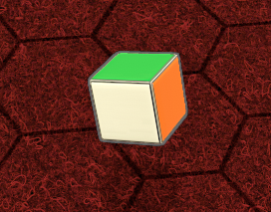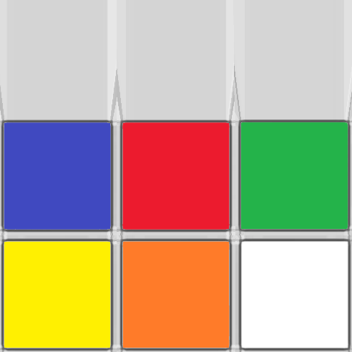

## Base piece

The base piece will be where the players are beginning from and they will move their player pieces from there. Each player will have one base piece and place one in the for furthest corners of the board.

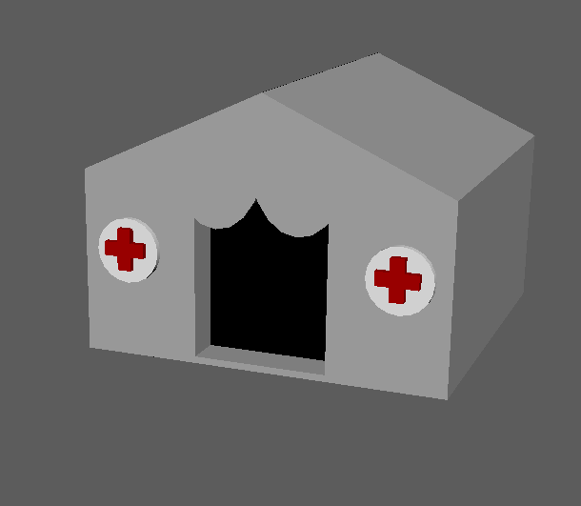

## Player piece

The player piece will be a counter for the player to navigate around the board to destroy the virus pieces and vaccinate the board.

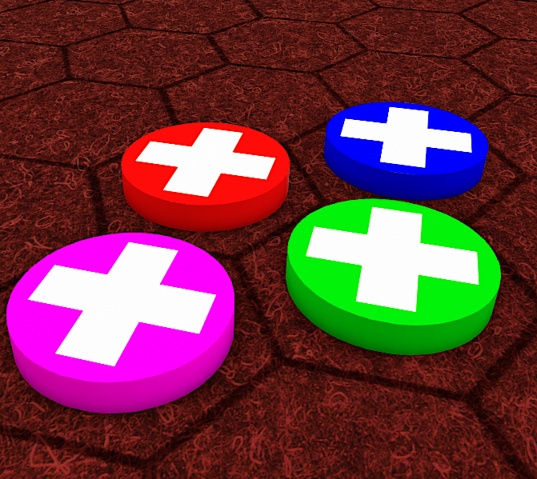

## Board pieces

This is literally the board it will be split up into 20 different pieces. Each piece will be made up of 4 hexagon pieces that will all slot together to make a uniquely shaped board. As players are able to decide where they place the pieces the game will look and play differently each time that you play. This idea was inspired from the game battle sheep which is the same.

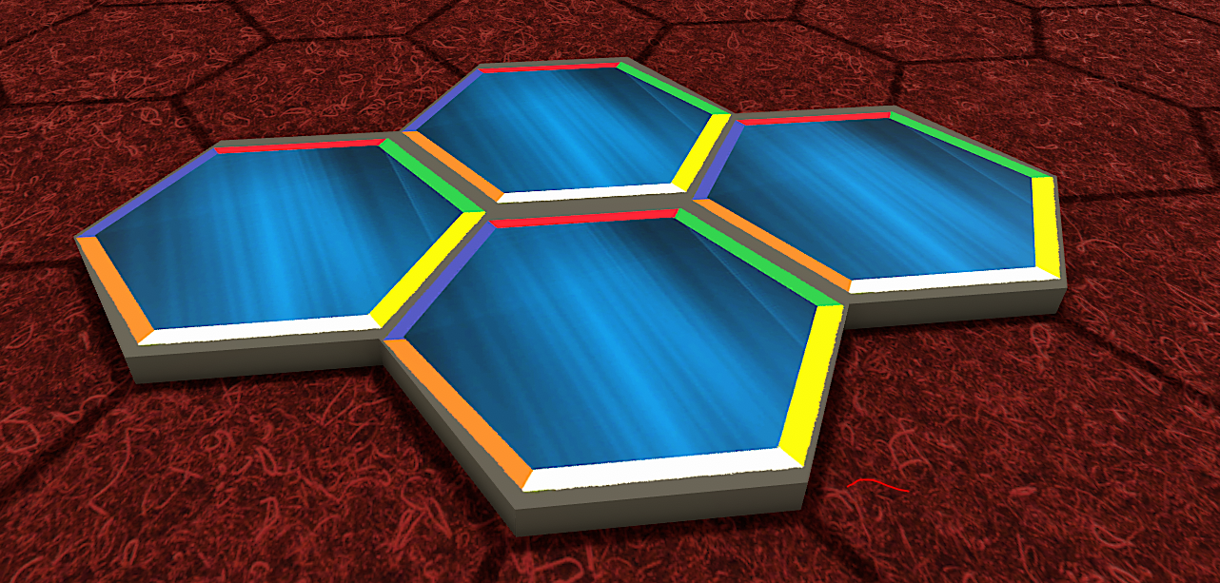

## Research pieces

These pieces will determine whether the player will be able to get vaccine cards for the game to help them purify the board

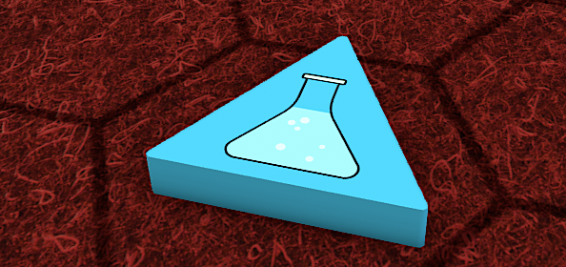

## Virus Pieces

These are the pieces that are used to indicate the virus’ position on the board

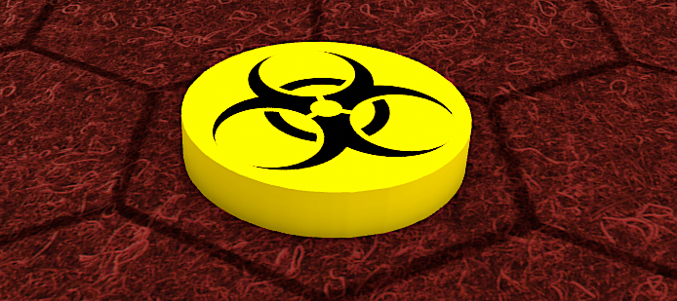

## Player Board Tracker

A player board used to organise information about that given player

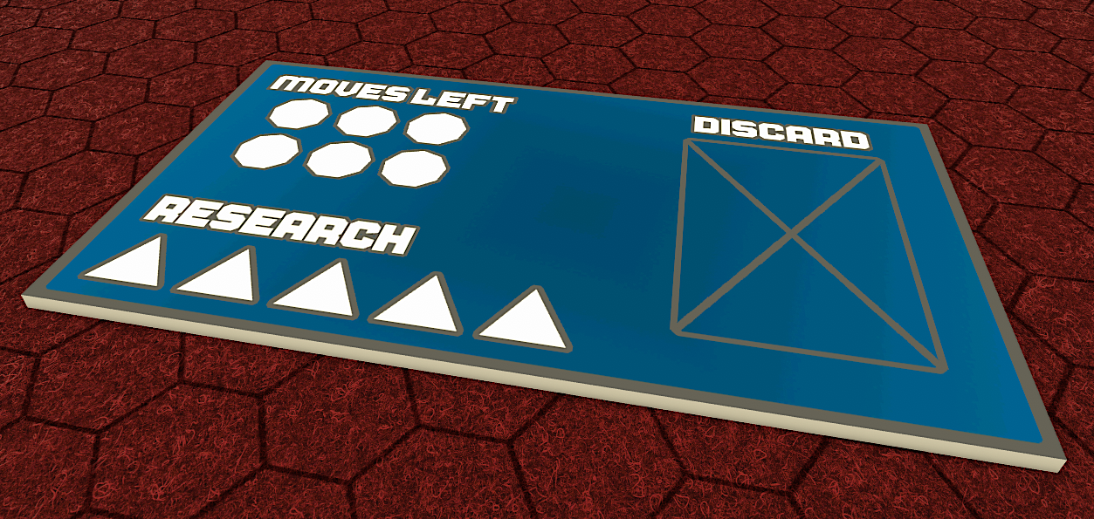

## Move Point Pieces

Pieces used to indicate how many move points a player has left

